EE 533 02/04/2023

Lab VII Report
Abdullah Alenezi, Brendan Santos, Daniel Briones, Mehul Kumar

1- Using the NetFPGA with DETER

Physical Lan/Link Mapping:
ID Member IP MAC NodeID
--------------- --------------- --------------- -------------------- ---------
lan0 n0:0 10.1.0.3 a0:36:9f:0a:0f:ee cpc18
4/1 <-> 6/16 HP2e2
lan0 nfrouter:0 10.1.0.2 00:4E:46:32:43:03 nf8
3/1 <-> 2/12 HP18c1
lan1 n1:0 10.1.1.3 a0:36:9f:09:29:12 cpc14
4/1 <-> 9/16 HP2e2
lan1 nfrouter:1 10.1.1.2 00:4E:46:32:43:02 nf8
2/1 <-> 2/11 HP18c1
lan2 n2:0 10.1.2.3 a0:36:9f:09:28:7a cpc16
4/1 <-> 9/4 HP2e2
lan2 nfrouter:2 10.1.2.2 00:4E:46:32:43:00 nf8
0/1 <-> 2/9 HP18c1
lan3 n3:0 10.1.3.3 a0:36:9f:0a:5c:9e cpc25
4/1 <-> 4/22 HP2e2
lan3 nfrouter:3 10.1.3.2 00:4E:46:32:43:01 nf8
1/1 <-> 2/10

Looking at the email sent from DETER, it is notable that the nf2c members (0-3) are not displayed in order. The key is to look at the last two hex digits of the MAC address in order to map to the proper nf2c member (highlighted above). For example, above, the number “00” in MAC address “00:4E:46:32:43:00” for lan0 corresponds to nf2c0. Thus, that MAC should have the IP address “10.1.0.2” assigned to it.

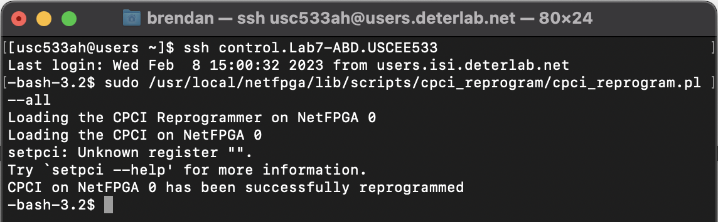
Command must be run after every reboot of NetFPGA computer

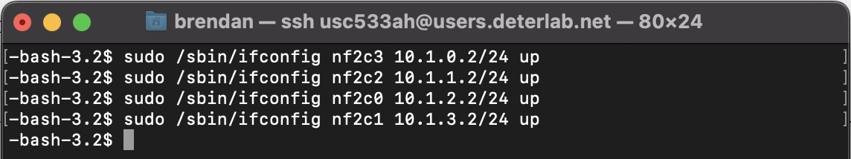

Using the MAC address and IP address mapping, all four ports were configured with their corresponding IP addresses using the commands shown above.

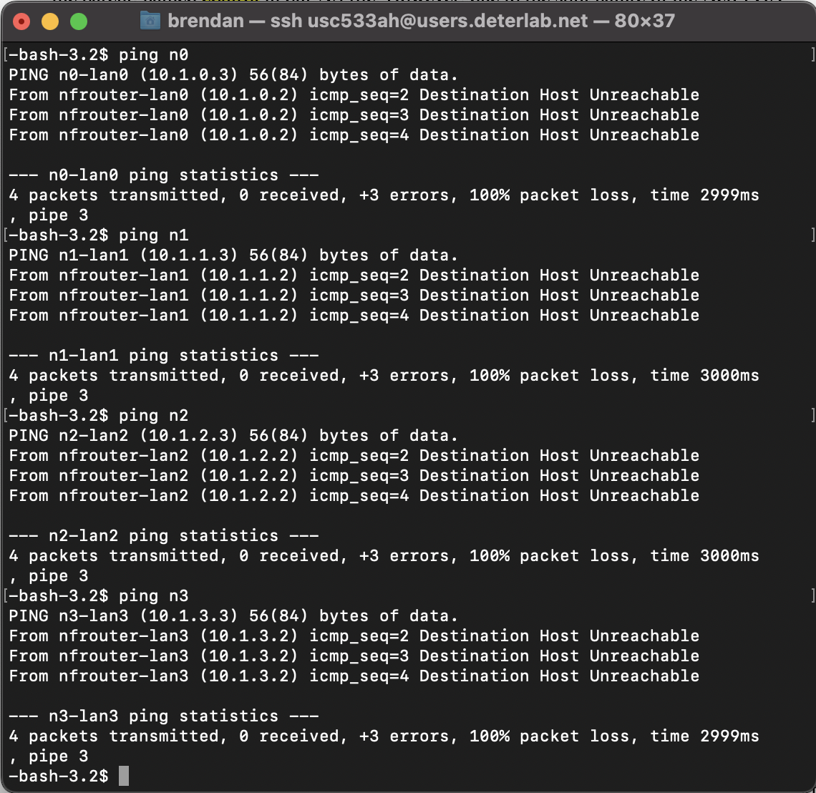

At this point, none of the nodes were able to be pinged from the control PC, as shown above.

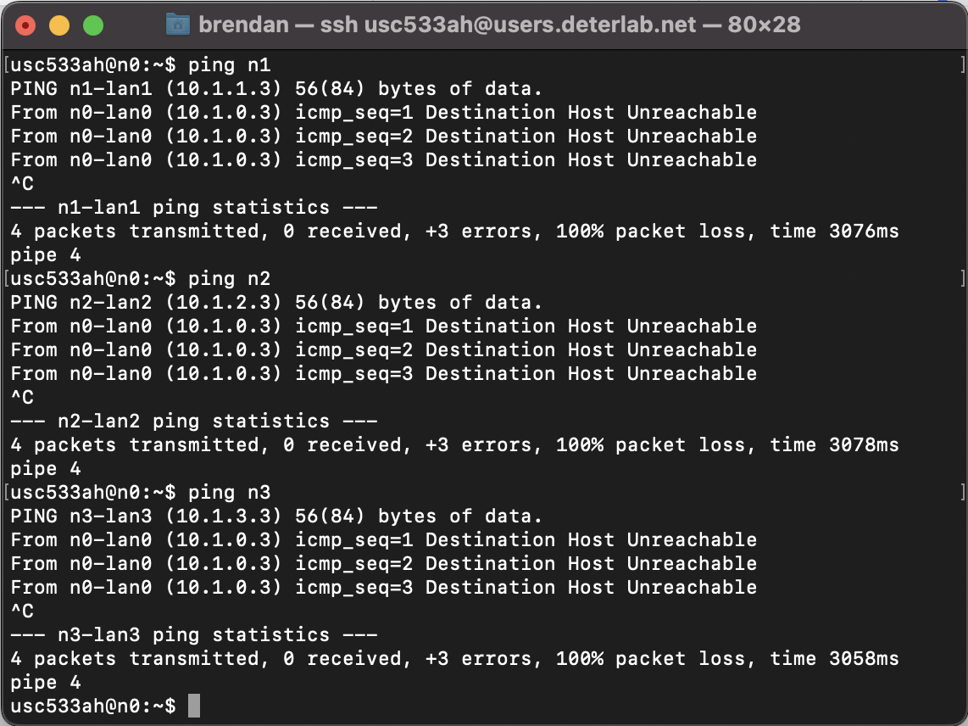

Additionally, using n0 as an example above, the nodes were unable to ping one another as well.

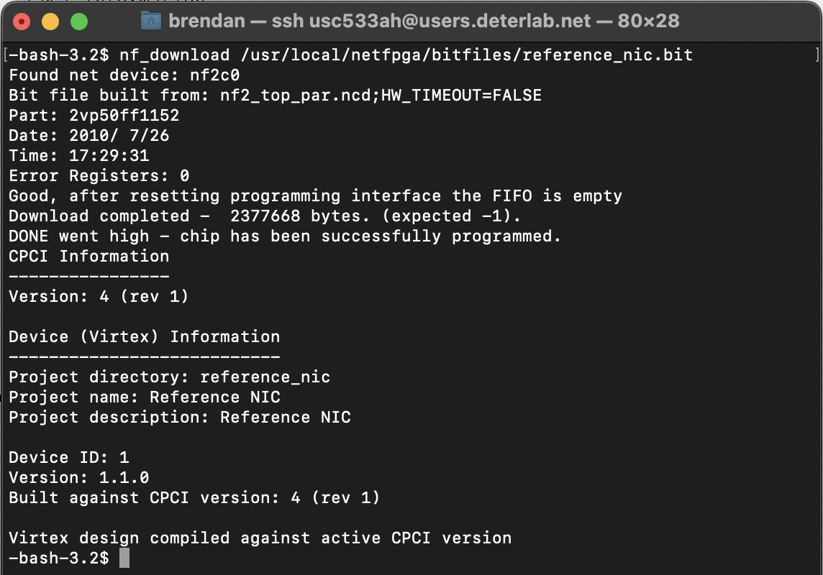

Once the above command was run, all nodes were able to be pinged from one another as evidenced below:

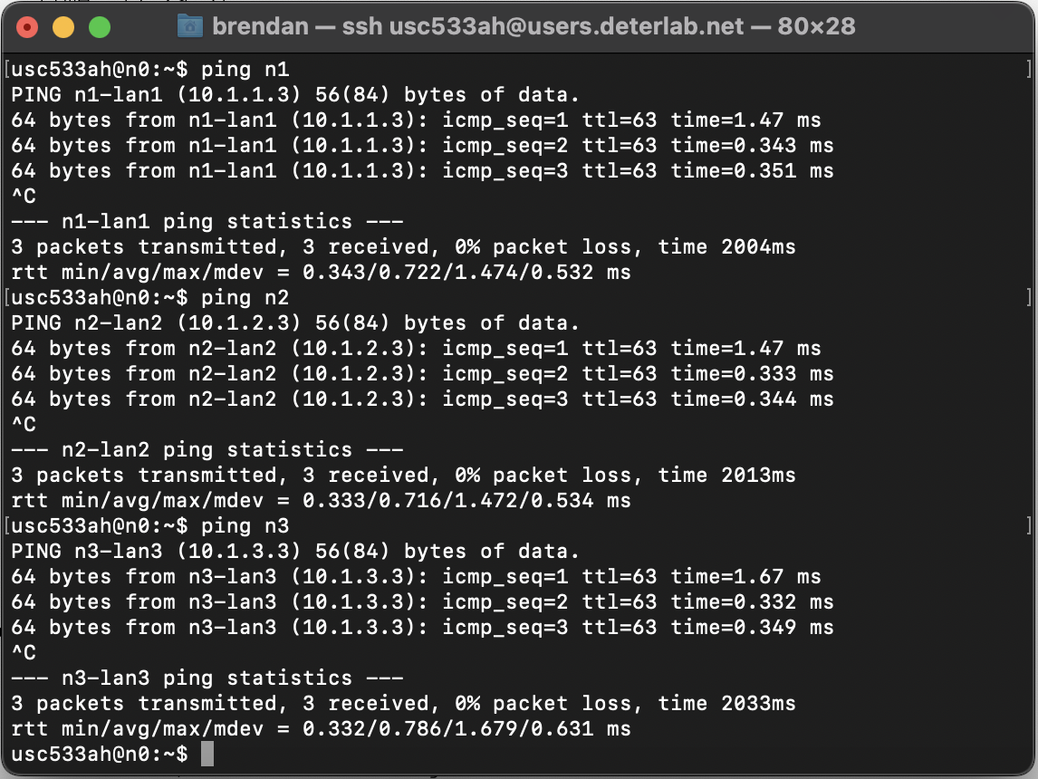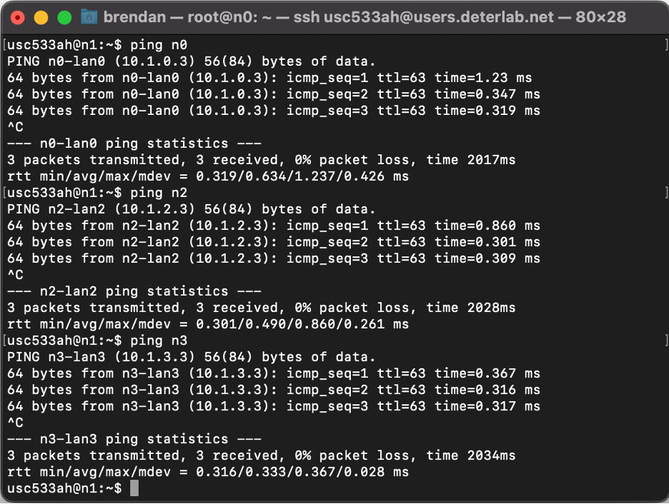
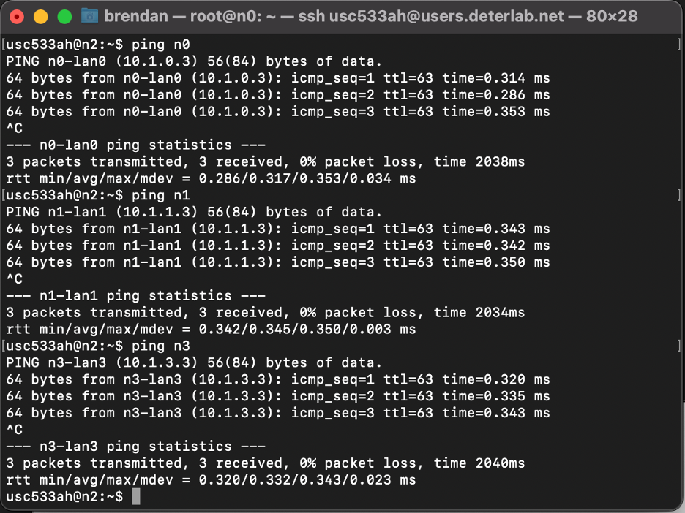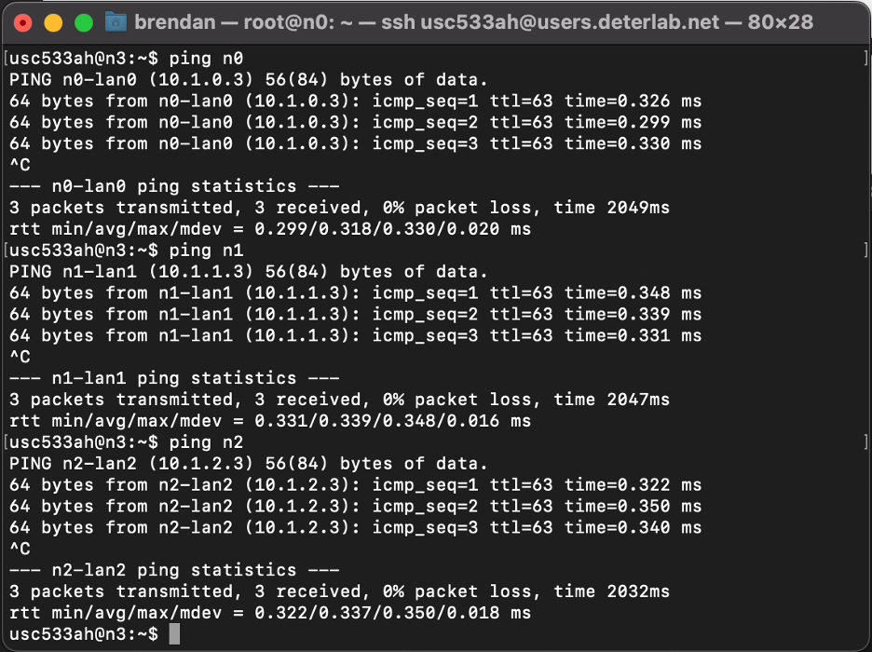

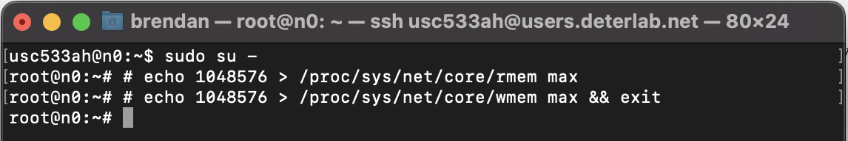
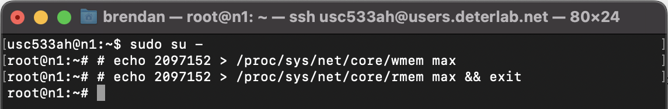

In theory, the above commands increase the send buffer size (wmem) and the receive buffer size (rmem) to the max value allowed.

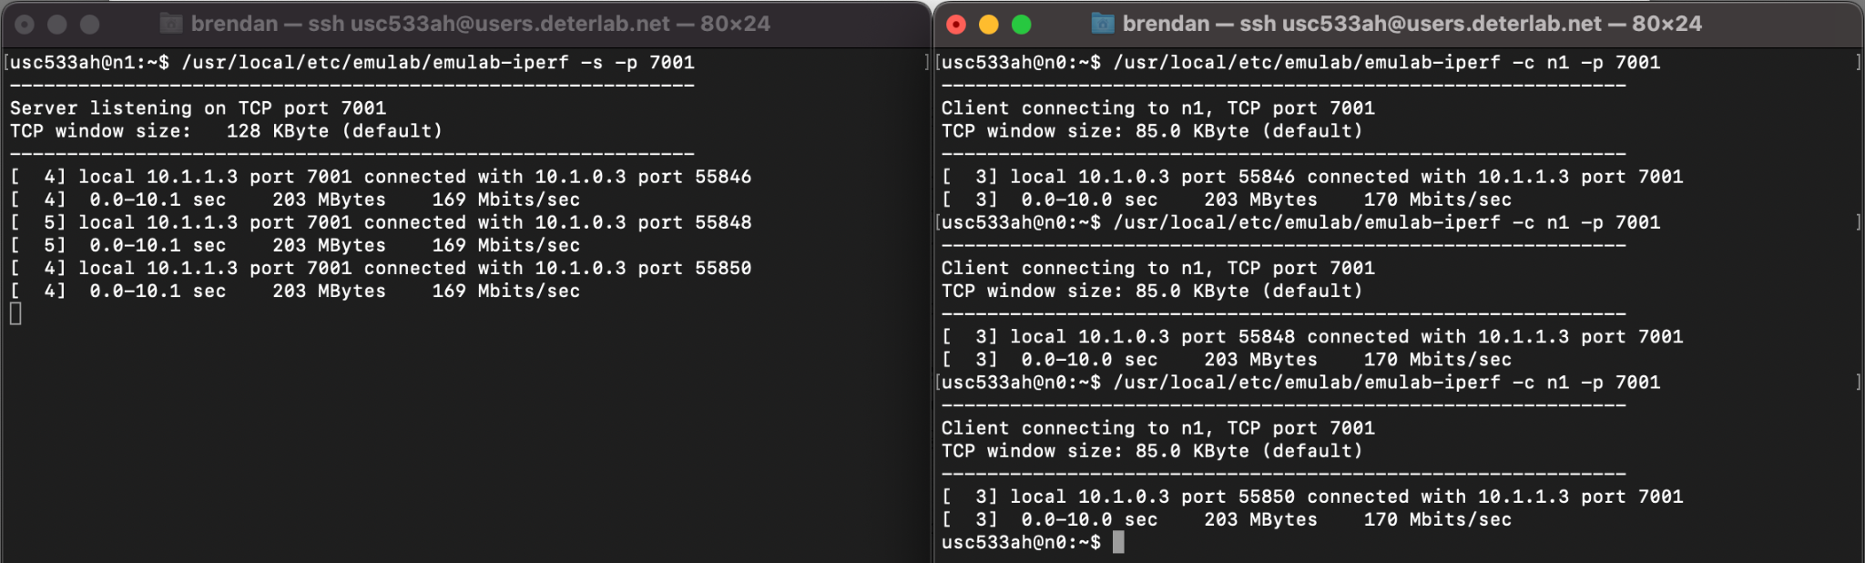

Using iperf in TCP mode with the server on n1 and the client on n0, the TCP throughput/bandwidth was measured to be 169 Mbits/sec, which is extremely low. This poor performance is due to the NetFPGA not yet being configured into a router.

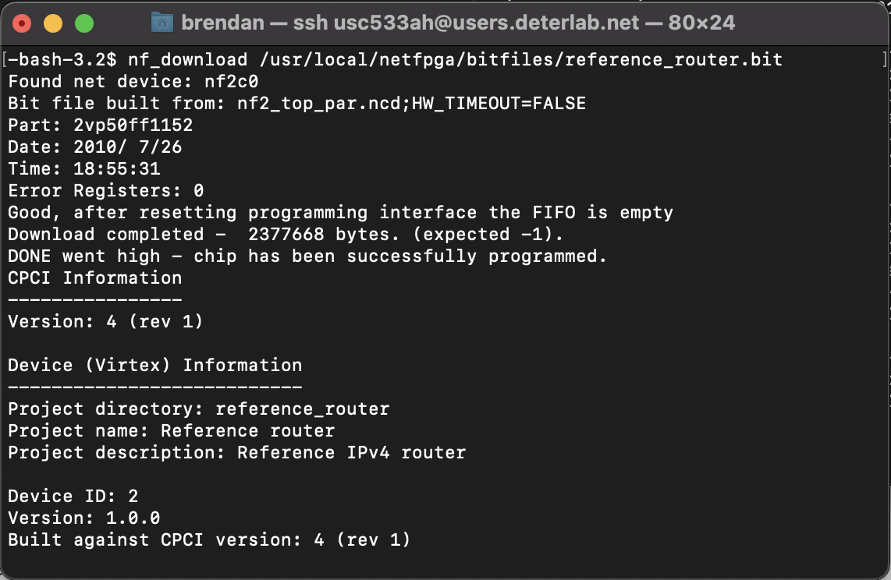

The above command loads the reference router into the NetFPGA.

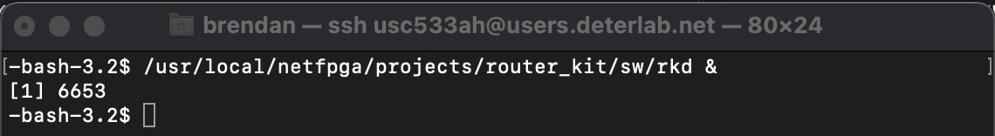

Additionally, the above command loads all necessary information regarding routes and IP addresses from the Linux kernel into the NetFPGA routing table in order to accelerate the routing process.

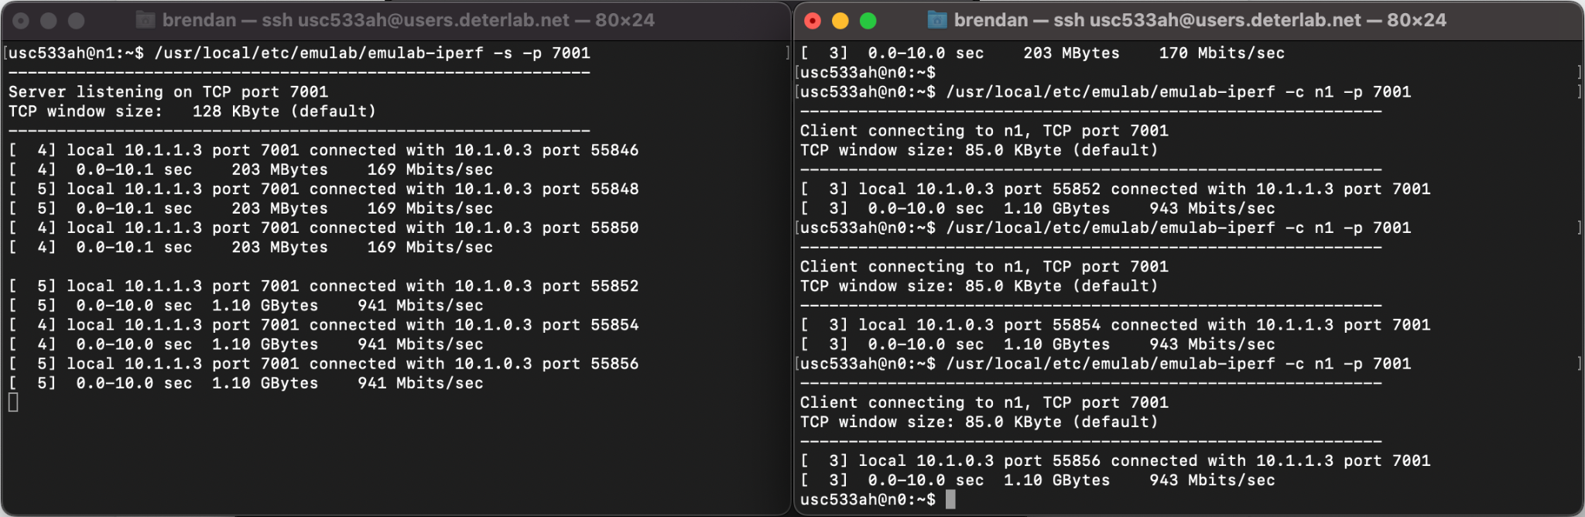

Now, rerunning the TCP iperf test, the bandwidth is observably much higher at 941 Mbits/sec as opposed to the 160 Mbits/sec. This increase in bandwidth is attributed to the NetFPGA now being configured as a router with optimizations to the routing process.

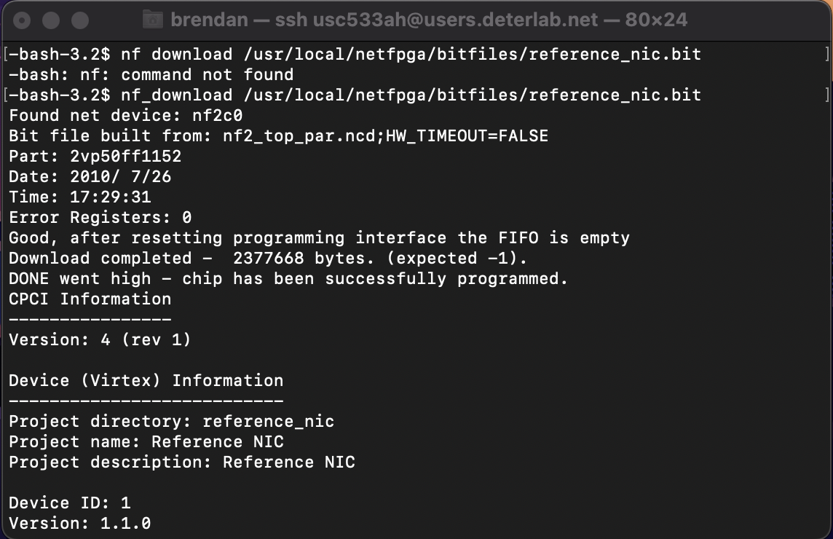

Following this, the reference_nic.bit file was loaded and an iperf server in UDP mode was run on each node. Then, from users.isi.deterlab.net, the setup.py and iperf_parallel.sh scripts were run to launch an iperf UDP client on each node:

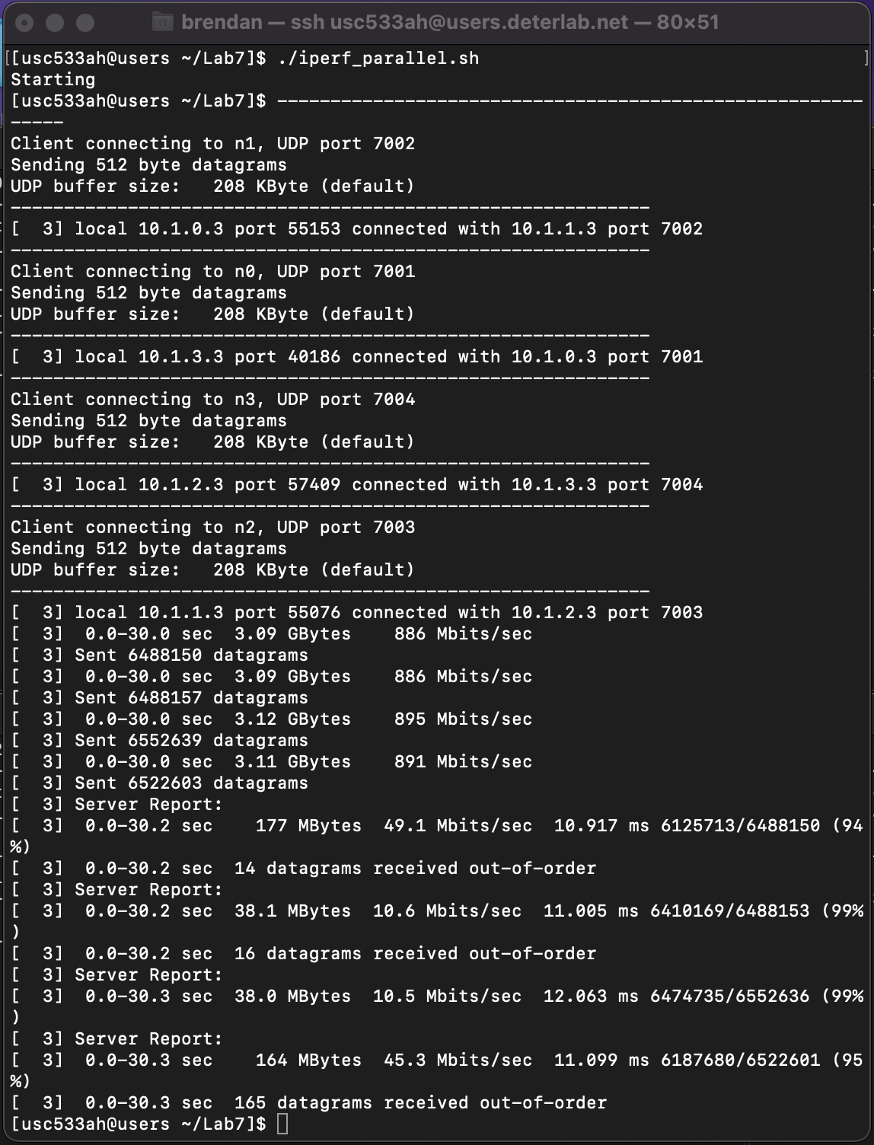

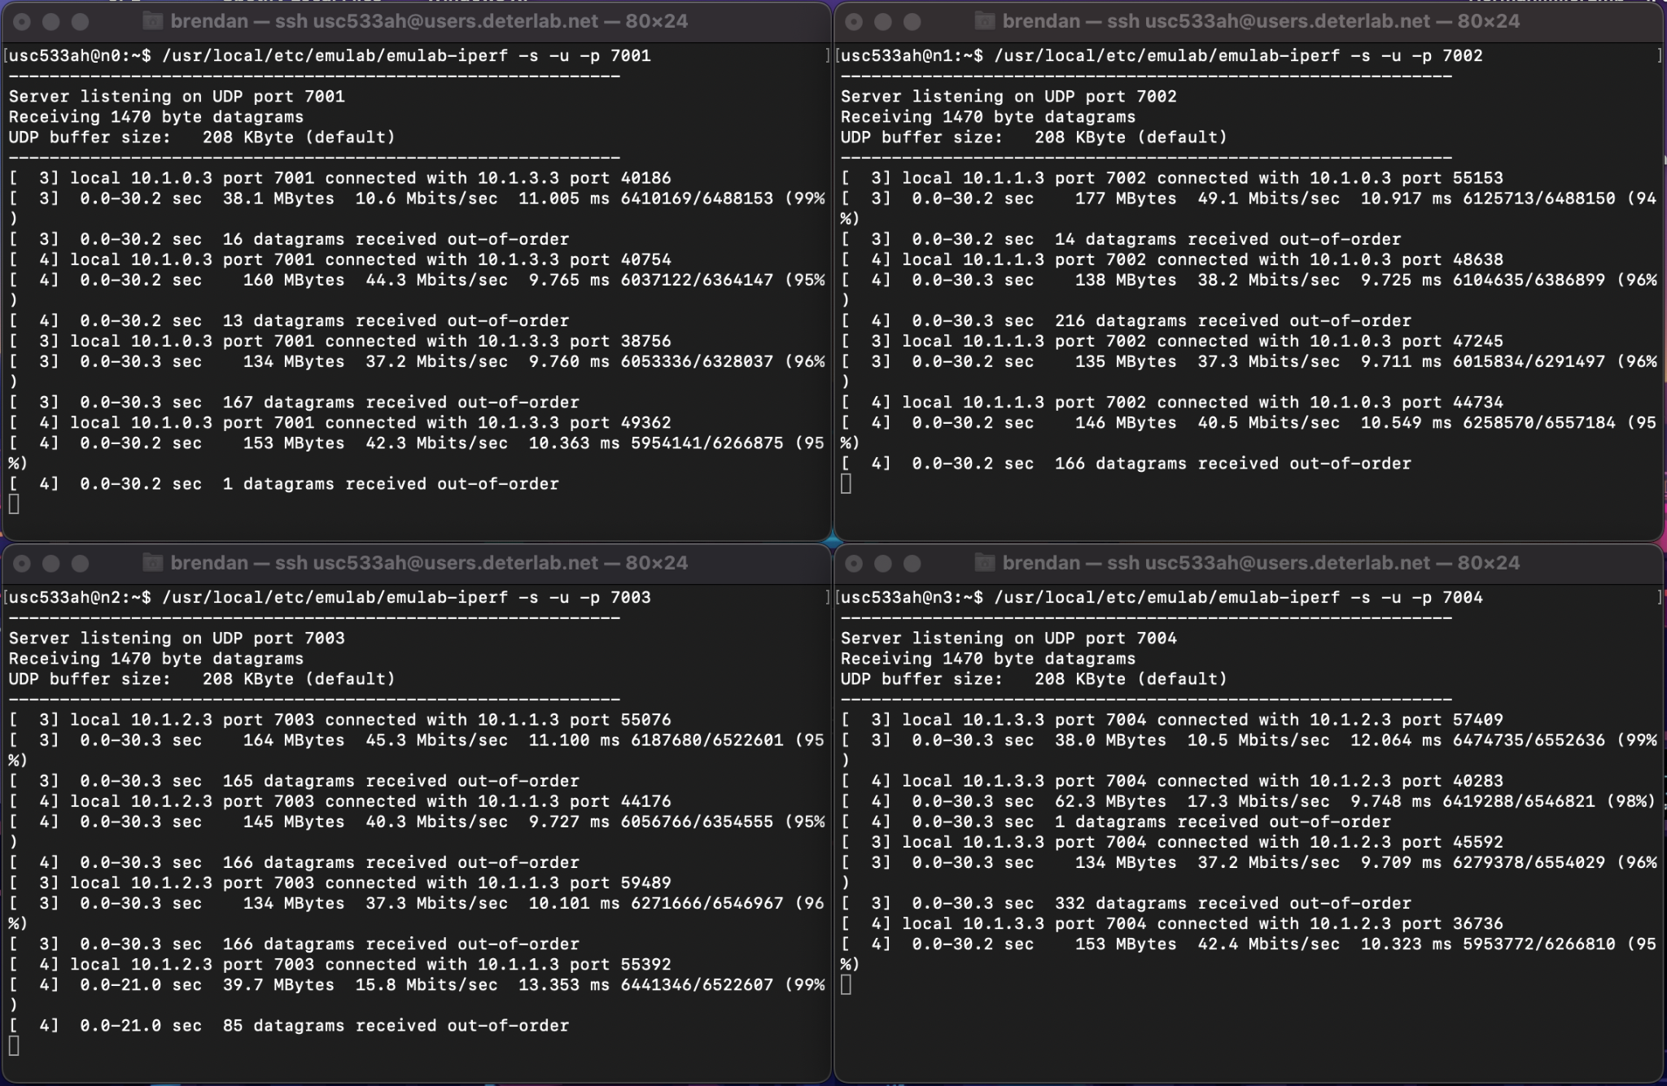
Looking at the server outputs above, poor throughputs in the ~15-45 Mbps range and data transfer sizes ~130-165 MBytes were being reported due to the sending of small packets. These small packets stress the system because each new packet is representative of a software interrupt, and thus having smaller packets equals more packets total. The large number of packets causes a large number of interrupts to be processed.
Afterwards, the same UDP iperf test was performed with the reference router.bit file downloaded and the rkd daemon started:

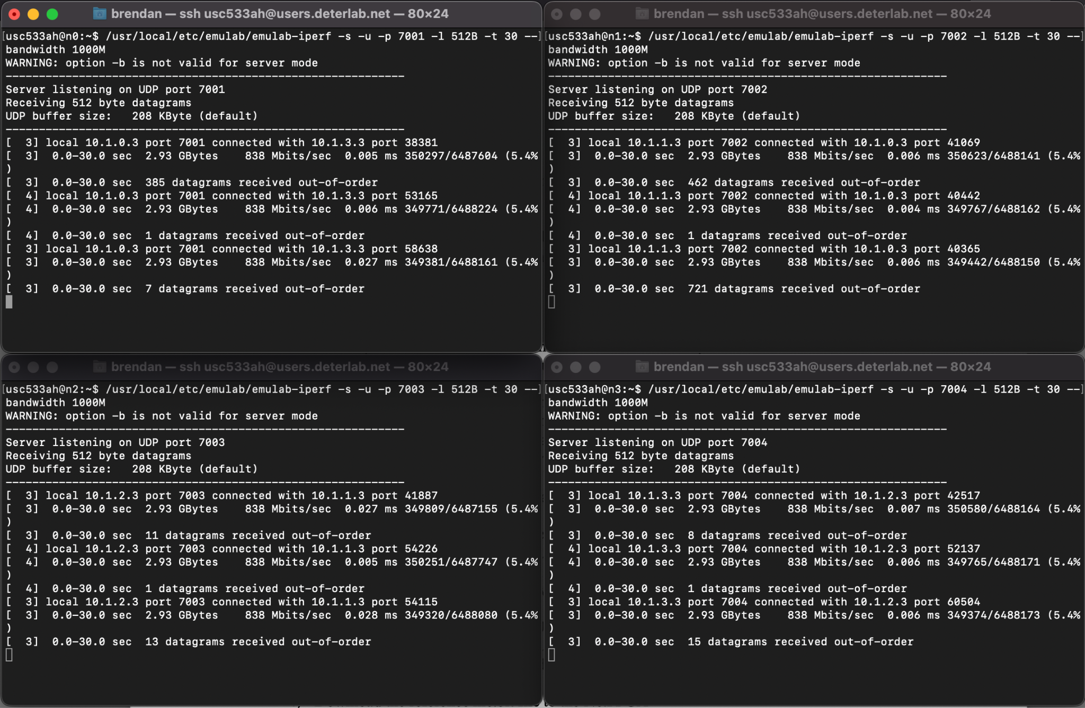
Observing the new server outputs above, greater throughputs of exactly 838 Mbps and data transfer sizes of 2.93 GBytes were reported. Based on these values, however, it is not fair to say that the NetFPGA can route IP traffic bi-directionally at line-speed for 4Gbps of cross-wise bandwidth.
2 - Synthesizing and Testing Custom NetFPGA bitfiles

The ids_passthrough.v module was constructed by simply connecting the inputs of the IDS module to its outputs. After adding each module individually and generating the bitstream, we found that the ids.v was preventing the nodes from being able to ping each other. We fixed this issue by observing ids_sim.v had different connections to the fifo and making our ids.v match this. After doing this, the nodes were able to ping each other and the IDS was able to intercept traffic properly.

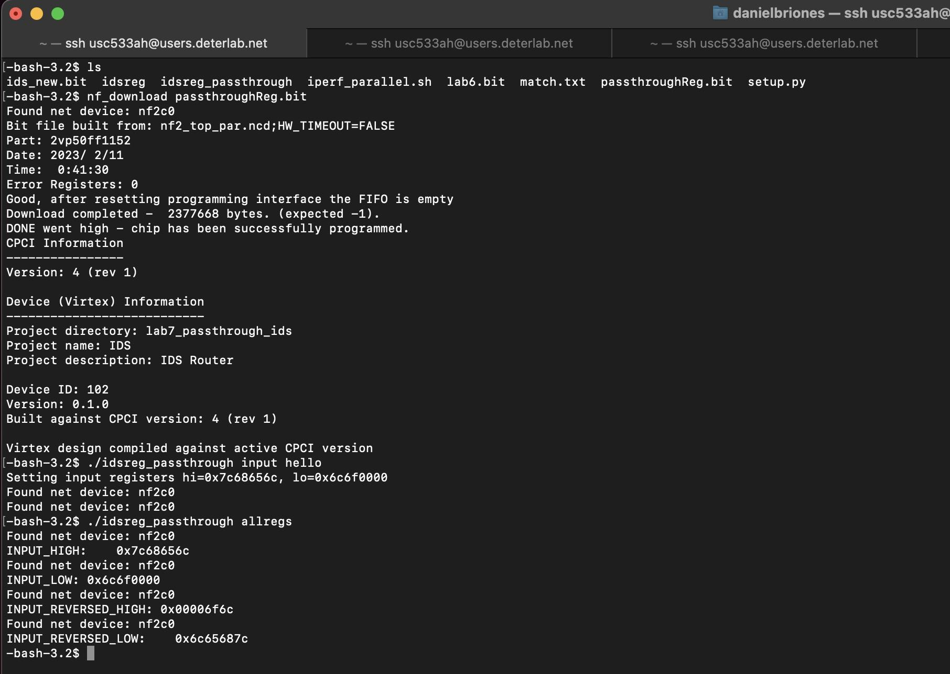

Screenshot above shows a write to the idsreg_passthrough input registers and a read from the very same registers, but with the input reversed.

3 - Synthesizing, Testing, and Debugging the mini-IDS

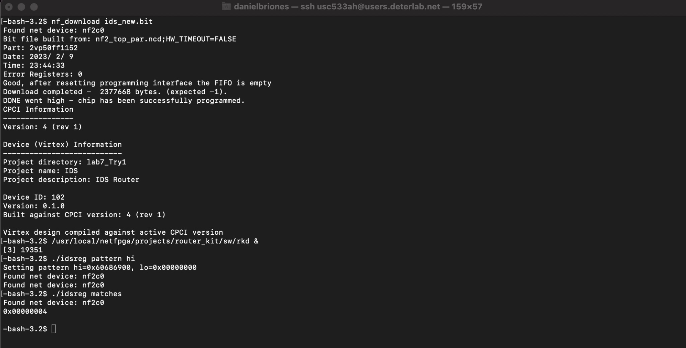

First step is to download the new bitfile “ids_new.bit” and upload it to the NetFPGA using nf_download. After confirming that the nodes could ping each other, the rkd process was started.

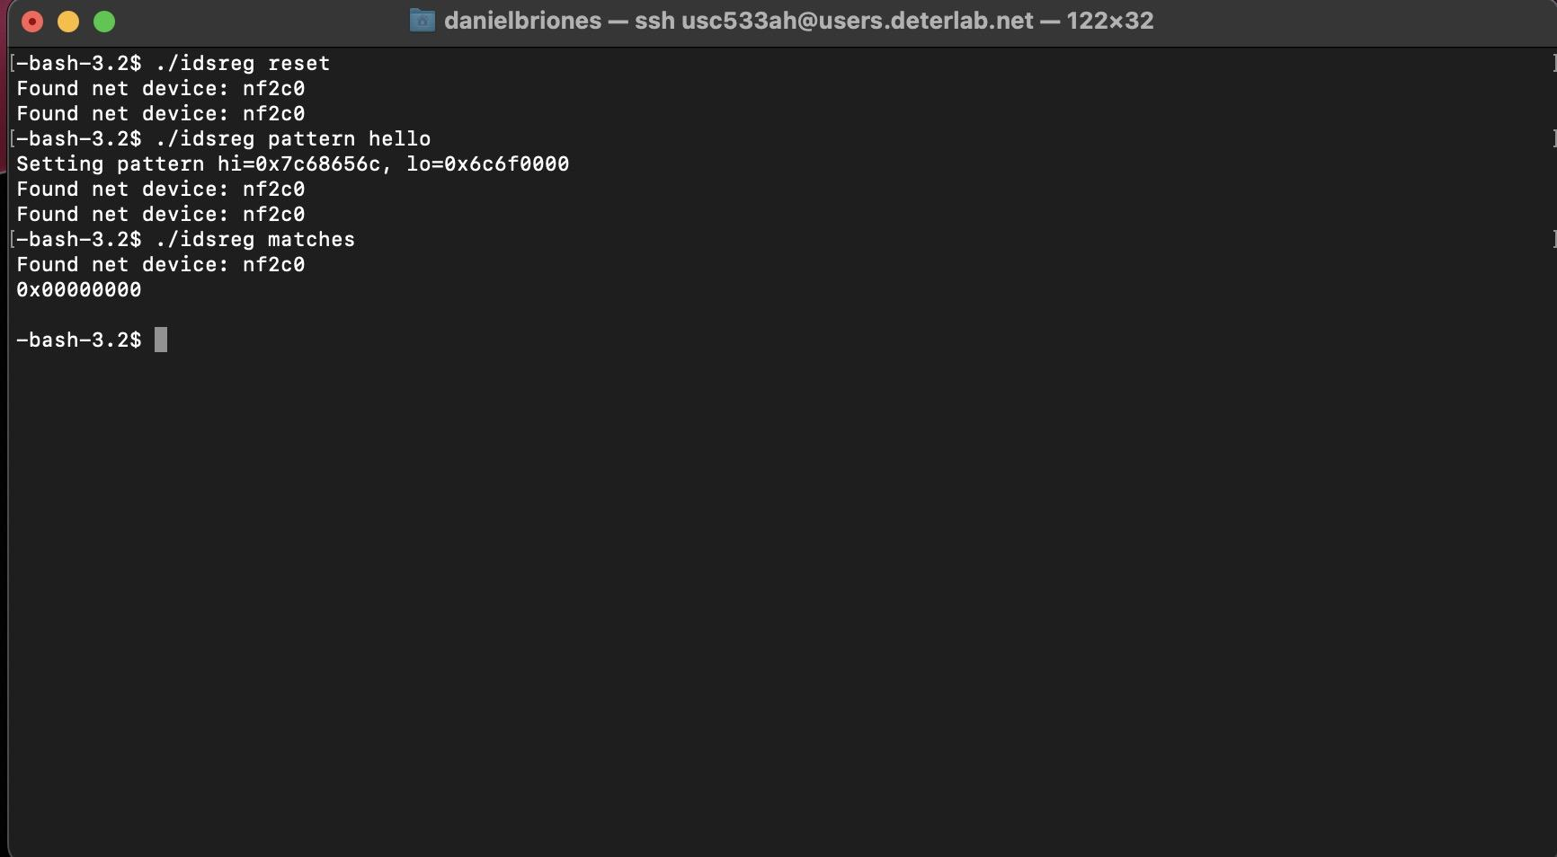

Because the previous step showed that the match register was reading a non-zero value, it was necessary to reset it. Afterwards, the pattern to be matched was set to “hello”. As the screenshot above shows, the idsreg match register is empty after reset.
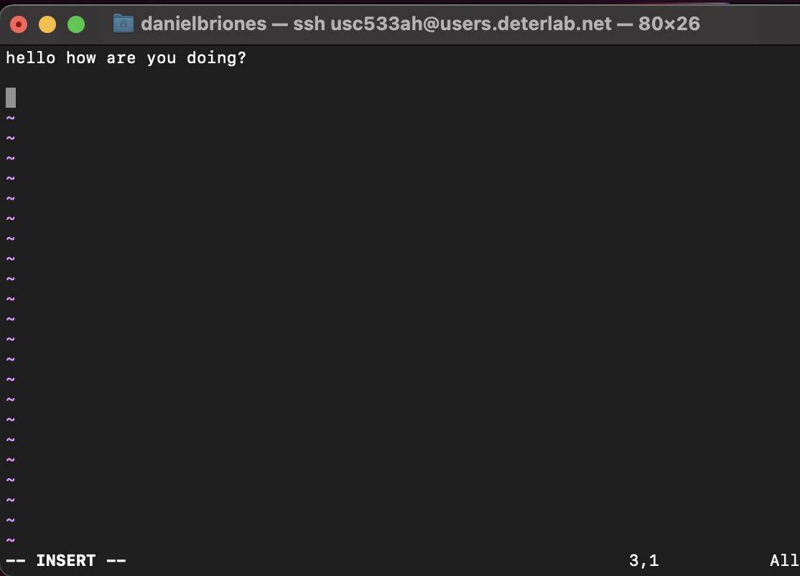
(hello.txt)

A hello.txt file was created to send over UDP/TCP. This is an example of “bad” data.

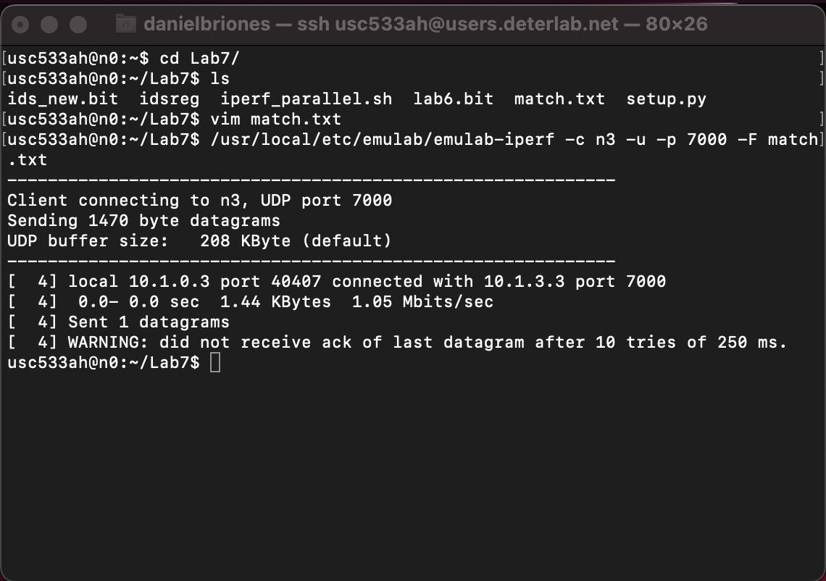

n0 attempted to send this hello.txt over UDP to n3 but no ack was received implying the packet never made it.

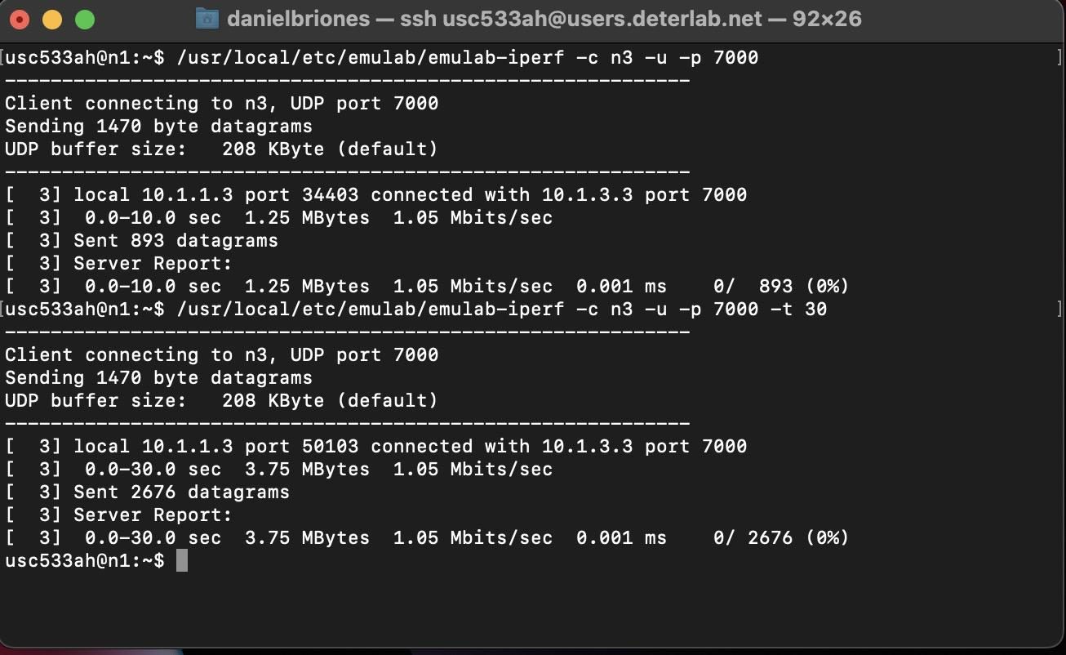

n1 communicates over UDP to n3 which is acting as the server. It is able to reach 1Mbps and communicate freely.
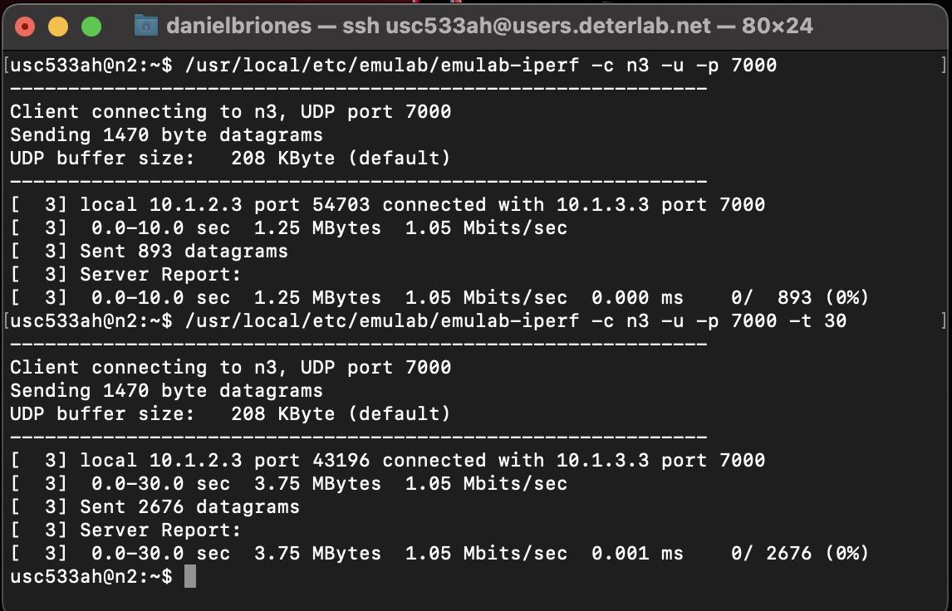

n2 communicates over UDP to n3 which is acting as the server. It is able to reach 1Mbps and communicate freely.

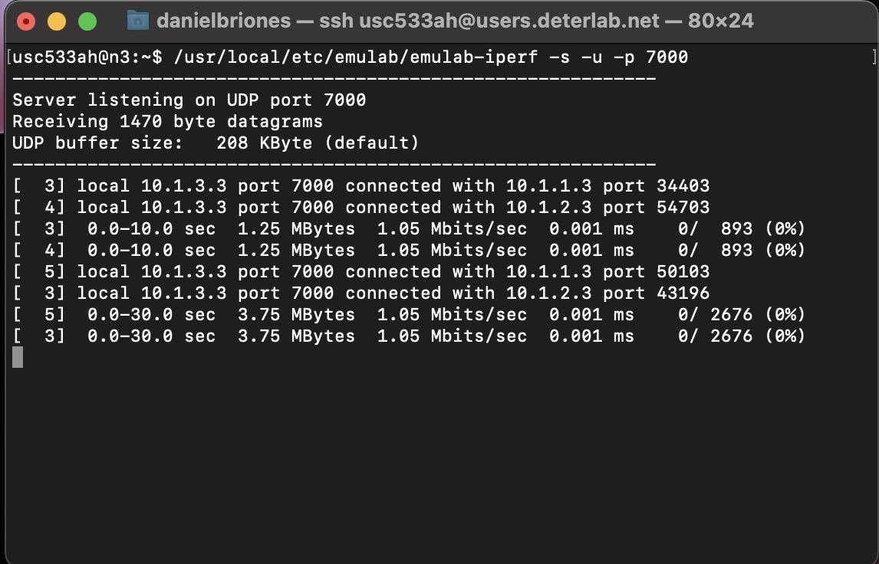

n3 acts as the UDP server listening at port 7000. It communicates with 10.1.1.3 (n1) and 10.1.2.3 (n2) but does not mention n0 (10.1.0.3) as the packets are intercepted by the mini-IDS.

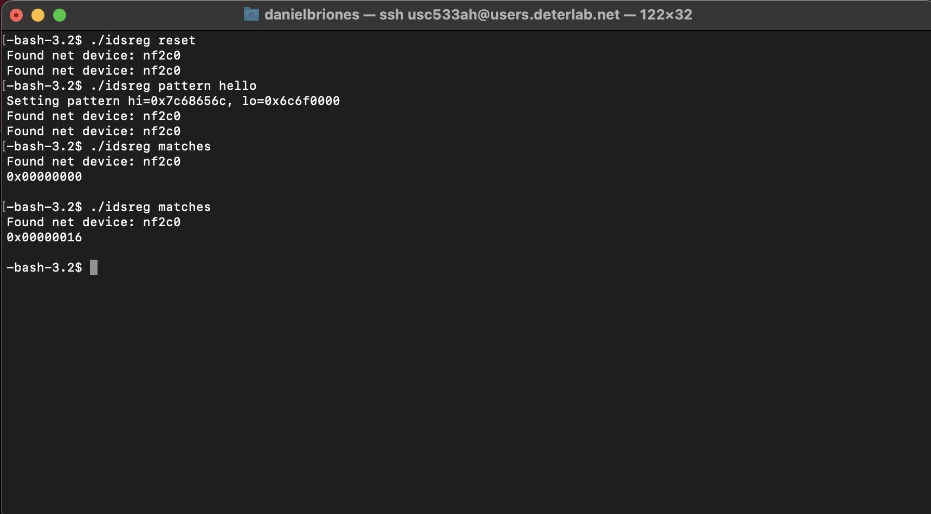

IDS match register shows that the “hello” string pattern has been matched (non-zero)

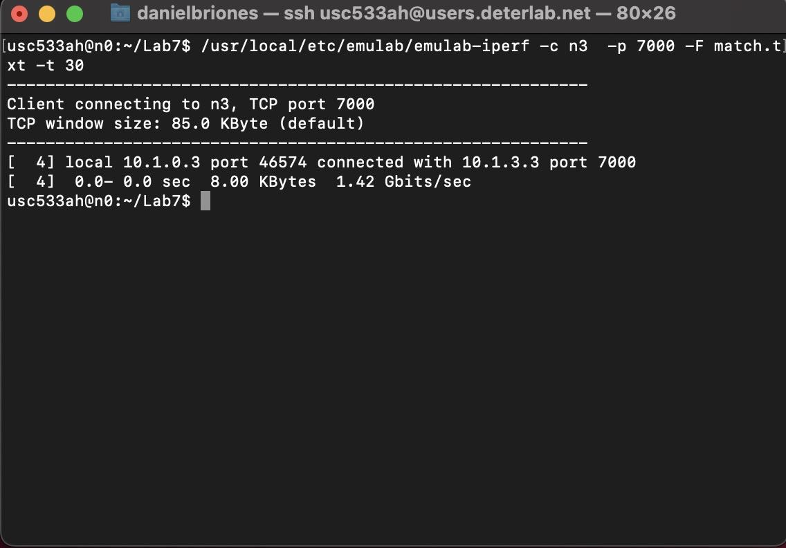

When attempting to connect via TCP, the connection fails as n0 is attempting to send the “bad” data. As shown above, the bandwidth figure occurs between 0.0-0.0 secs, essentially meaning it never occurred.

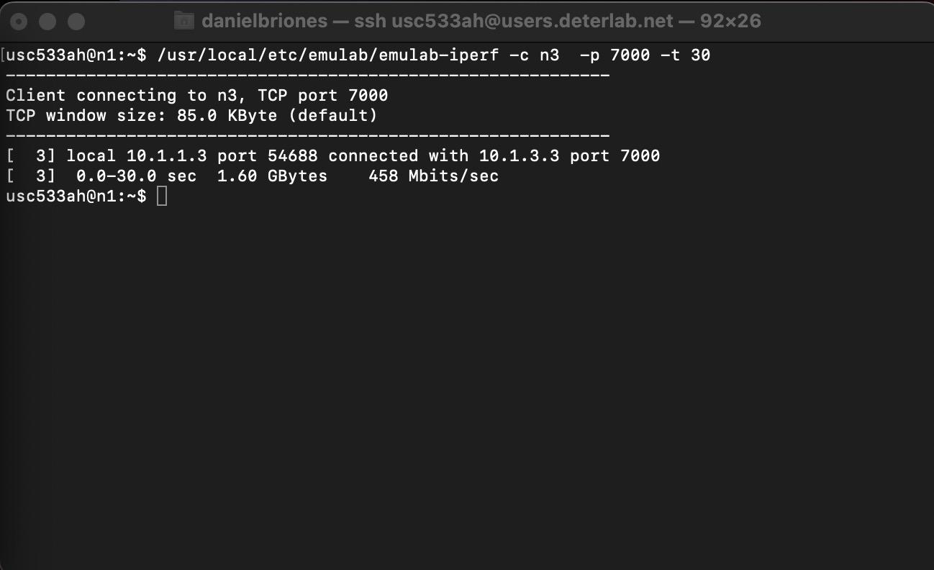

n1 communicates over TCP with n3 (server) and is able to achieve nearly half gigabit speed. This is to be expected with the high overhead of TCP and with n2 communicating as well.

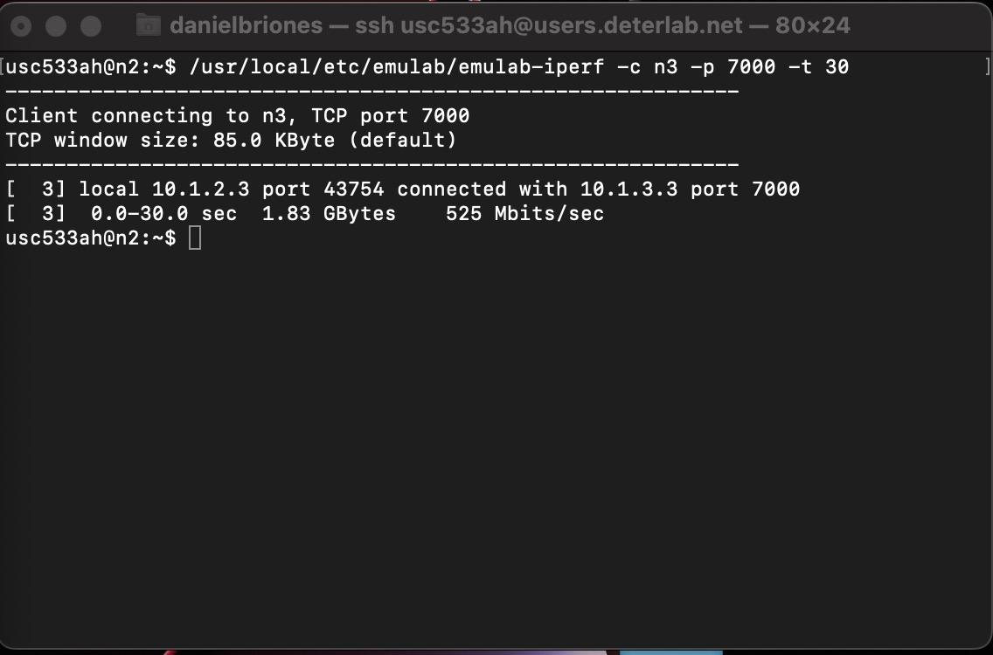

n2 communicates over TCP with n3 (server) and is able to achieve over half-gigabit speed. This is to be expected with the high overhead of TCP and with n1 communicating as well.

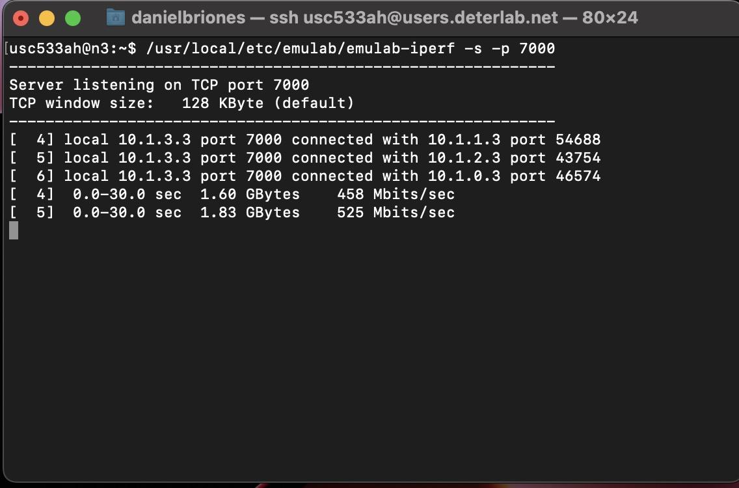
node 3 acts as the TCP server listening on port 7000. It acknowledges that all the nodes are connected. The following screenshots will show that data arrived from n1,n2 but not from n0 which sends the “bad” packets.
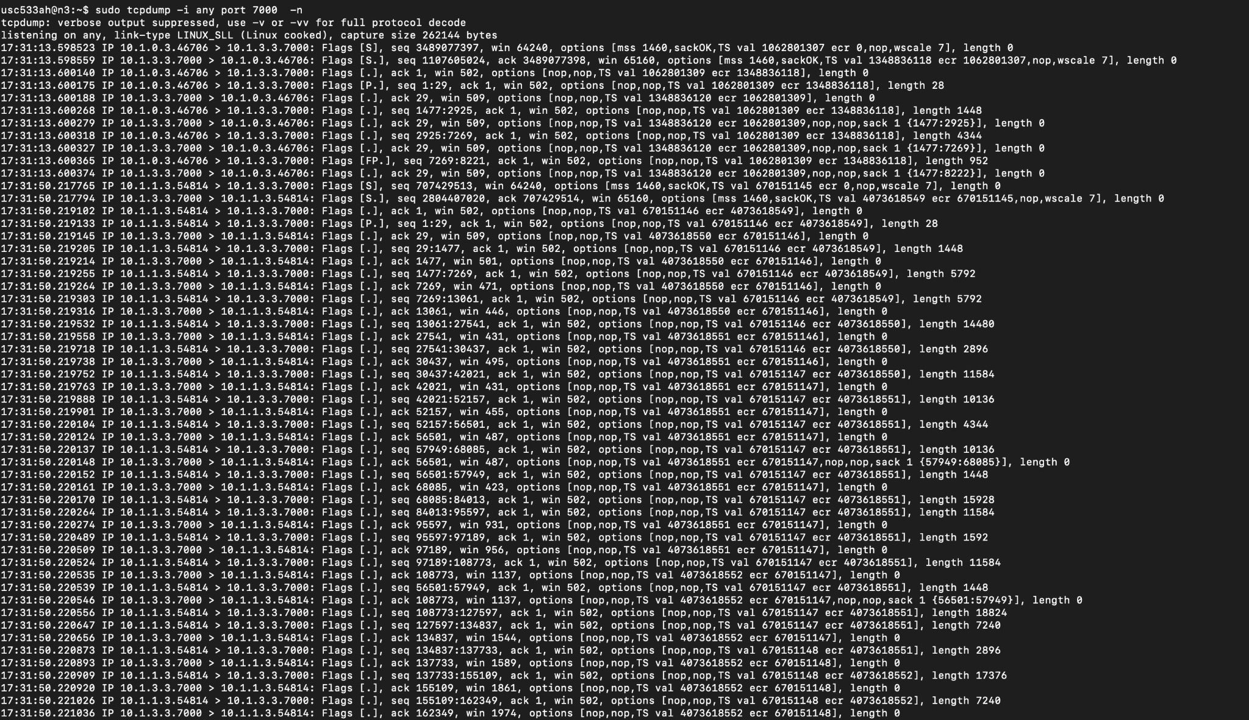
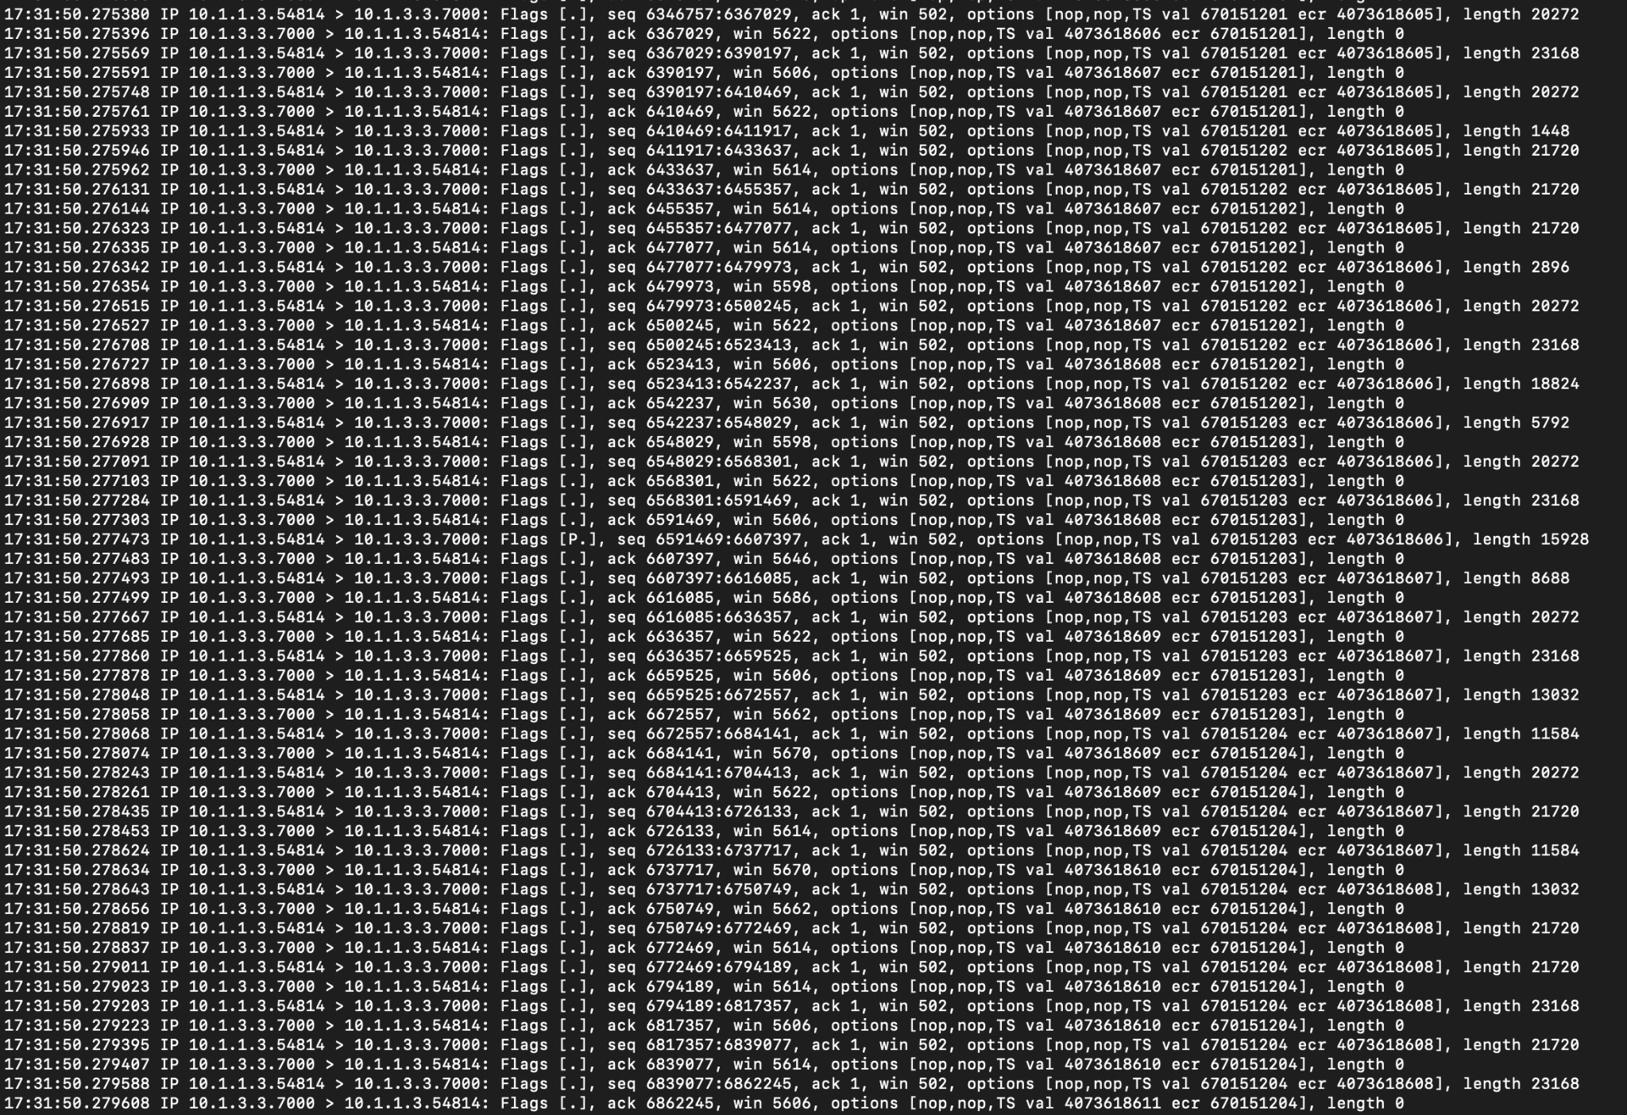

TCP dump shows communication between n0 (10.1.0.3), n1 (10.1.1.3), and n2 (10.1.3.3). As shown in the screenshots above, n1 and n2 send large packets over 10,000 bytes, but n0 is only able to send less than 30 bytes on average. This is due to the fact that the mini-IDS is intercepting the packets and the only packets making it through to the server are to establish the connection.

4 - Lab Questions

1. There is a bug when the mini-IDS is passing traffic at near gigabit speeds. What is the bug?

We did not find the bug within the mini-IDS.

2. Explain in brief how the mini-IDS works and how it interacts with the other modules in the
NetFPGA. Be clear and concise! Write as if you are describing the mini-IDS project on a
webpage where other NetFPGA developers will read about your design.

Mini-IDS is a module that sits between output port lookup and output queue. The output port lookup processes the packet and sends it to a MAC output port. Originally, this packet would go into an output queue and to the receiver, but the Mini-IDS intercepts the packet before it can reach the output queue. The Mini-IDS inspects the entire packet for a given pattern and if that pattern is a match, it sends it to a drop_fifo which drops the packet. Otherwise, the packet is forwarded to the output queue. In summary, the Mini-IDS acts as a “man in the middle” that intercepts packets and inspects them for “bad” data.

3. Explain the pattern matching algorithm.

The pattern matching algorithm utilizes a number of comparators to compare various bit alignments of incoming packet bits with the expected pattern in order to determine if a match to the pattern has been made. More specifically, the algorithm attempts to detect a 7-byte malicious pattern in and across an 8-byte word using various byte alignments. reg9B is used to store whatever the current 8-byte word is in pipe1 into pipe0. Once the register holds that word, it is then merged with the next word to be used for comparison using the busmerge module, which essentially takes a 48-bit input (in this case the lower 48-bits or 6 bytes of the previous word) and a 64-bit input (the current word) and merges them into a 112-bit output. This output is then used to be compared with a 64-bit input from hwregA and determine if there are any pattern matches made.

4. Draw a high-level design of the user_data_path.v and ids.v Verilog files. The figure should depict the communication between the components.

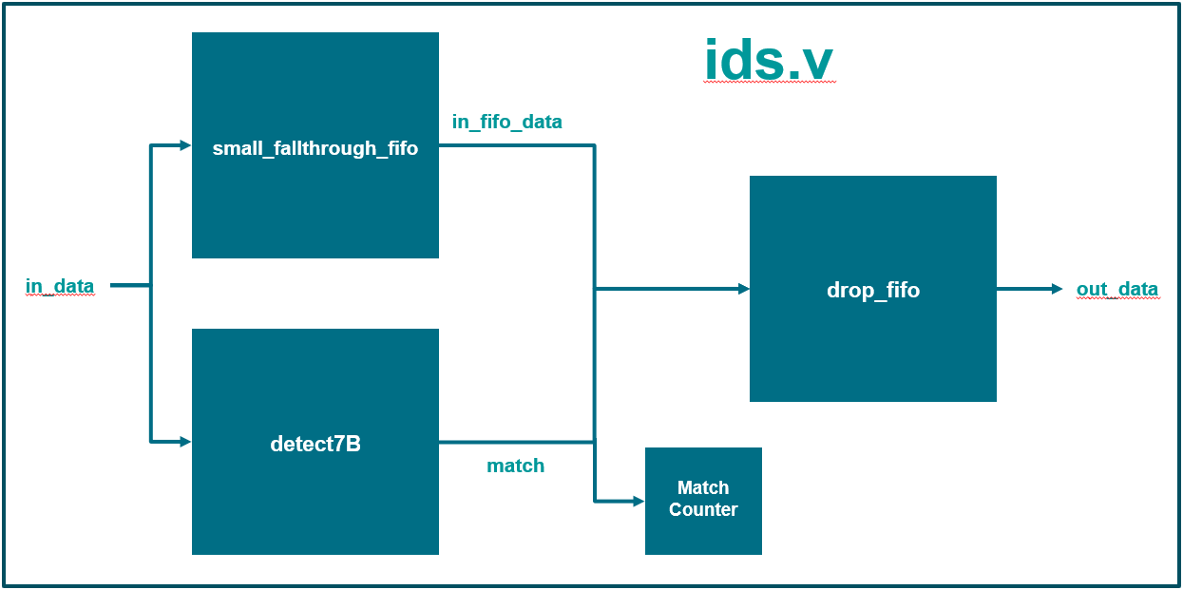
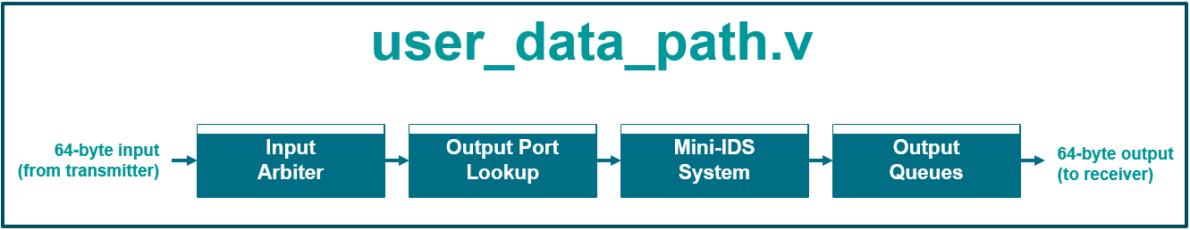

Note: Verilog and bit files submitted along with report on Blackboard

